Jeremy Perez

1. Initial diagram

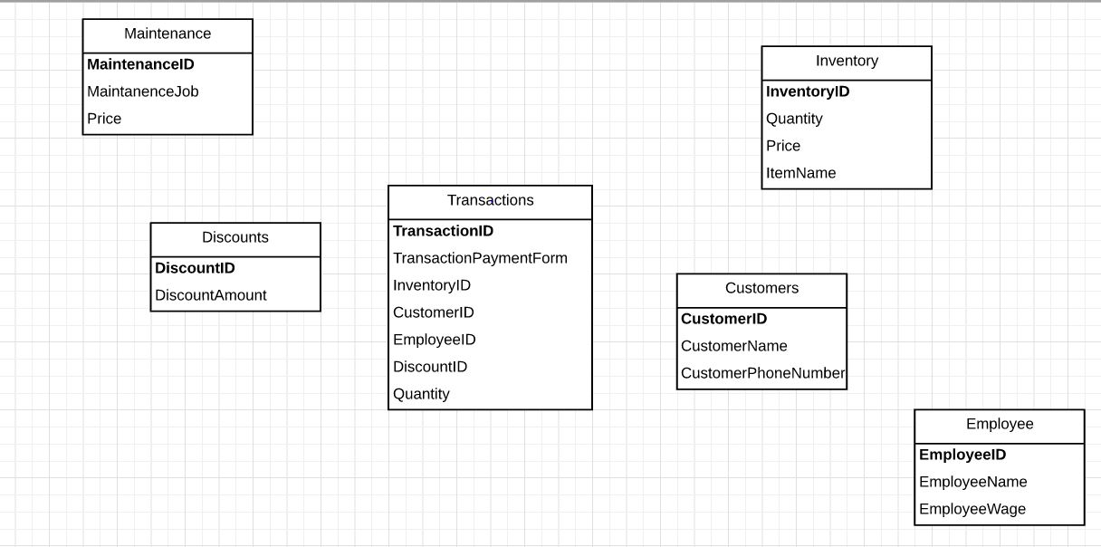

1. diagram in first normal form

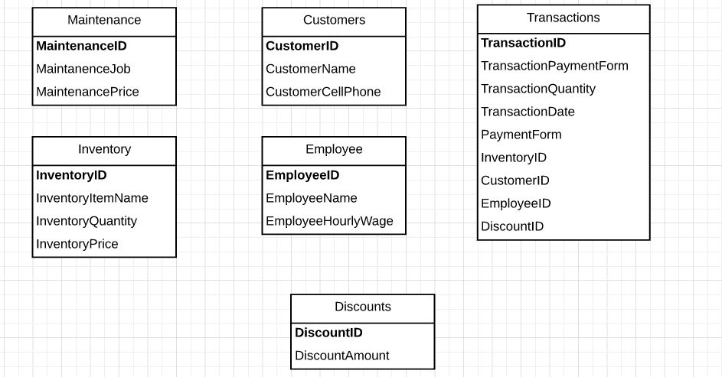

1. diagram in second normal form

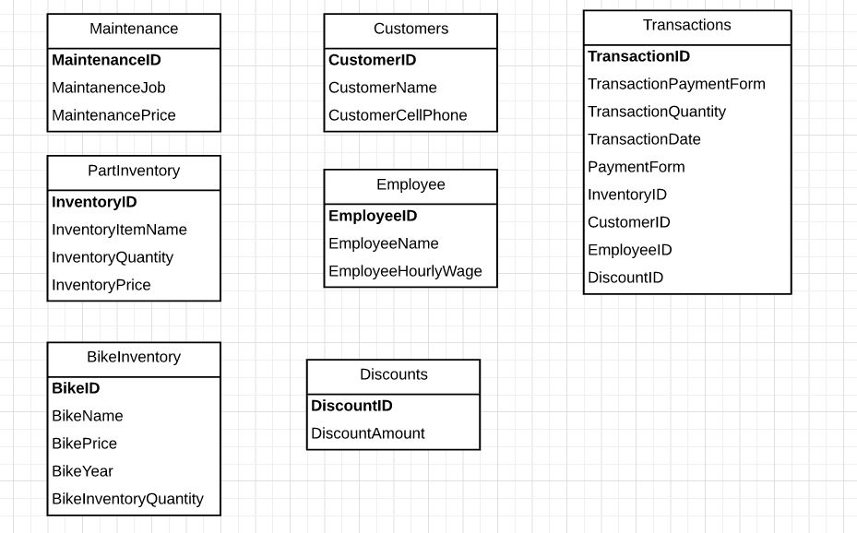

1. diagram in third normal form



1. Final diagram



1. List of business rules to check the db against

The db tracks the amount of inventory (bought, sold, remaining) and the best selling product.

The db tracks the sales of each product/service.

1. List of stakeholders

Owner

Employee

Customer

Vendor

1. Peer review of other group's ERD

* First field should be primary key in each table and bolded. (DiscountCode and InvoiceNumber are they keys for the Discount and Invoices table)
* TotalInventory and InventoryInvoices ids should not be the connection
* Vendor table, more specific contactFirstName, contactLastName
* Part number and partID in supplierinventory
* ReceiptNumber in ServiceReceipts table does not connect to Receipts table.
* Consistent naming of table and primaryID BikeSupplies and SuppliesInventory vs BikeParts and PartsInventory



* Is it in Normal Form?

This table is in normal form because their diagram does not have duplicate fields in the same table (1NF), their entities do not have duplicate fields within other tables (2NF), and the tables do not have transitive dependencies (3NF).

* What tables (in order) would you use to sell a customer
  + Bike Tuneup
  + Service >Service Receipt connects Employee (Not connected) > Receipts connects Customer
  + New Seat
  + Total Inventory connects Bike Inventory and Supplies Inventory to Bike Supplies > Inventory receipt connects discount > Receipt connects Employee and Customer
  + Tires
  + Total Inventory connects Bike Inventory and Supplies Inventory to Bike Supplies > Inventory receipt connects discount > Receipt connects Employee and Customer
  + Tire Installation
  + Service >Service Receipt connects Employee (Not connected) > Receipts connects Customer